Problem Assignment #5
Datapath and Simple CPU
ECE 2330 Digital Logic Design
Spring 2022
April 8, 2022
By Kevin Moody (km4ws)

Table of Contents
1 Problem Statement 2
2 Analytical Design 2
3 Numerical Verification 3
4 Summary 4

Table of Figures
Figure 1: Simple CPU Datapath 2
Table 1: Arithmetic Functions Defined by F1 and F0 2
Figure 2: Datapath Circuit 2
Figure 3: Register Circuit 2
Figure 4: ALU Circuit 2
Figure 5: Full Adder Circuit 3
Figure 6: Simple CPU Diagram 3
Figure 7: Full Adder Test Vectors 3
Figure 8: ALU Vectors 3
Figure 9: ALU Vector Results 3
Figure 10: Simple CPU Test Vectors 4
Figure 11: Simple CPU Vector Results 4
Figure 12: ProgramDataMemory Contents 4

1 Problem Statement
Design a datapath used to store all the information that is used to define the state of the Central Processing Unit (CPU) at any given time, essentially completing the simple CPU design (Figure 1).
The information is store in the Memory Address Register (MAR), Memory Buffer Register (MBR), Instruction Register (IR), Program Counter (PC), and Data register D0. The datapath also contains an Arithmetic and Logic Unit (ALU) that is used to perform the four arithmetic operations shown in Table 1, and there is an additional ALU register used to store the result of the arithmetic operation defined by F1 and F0.
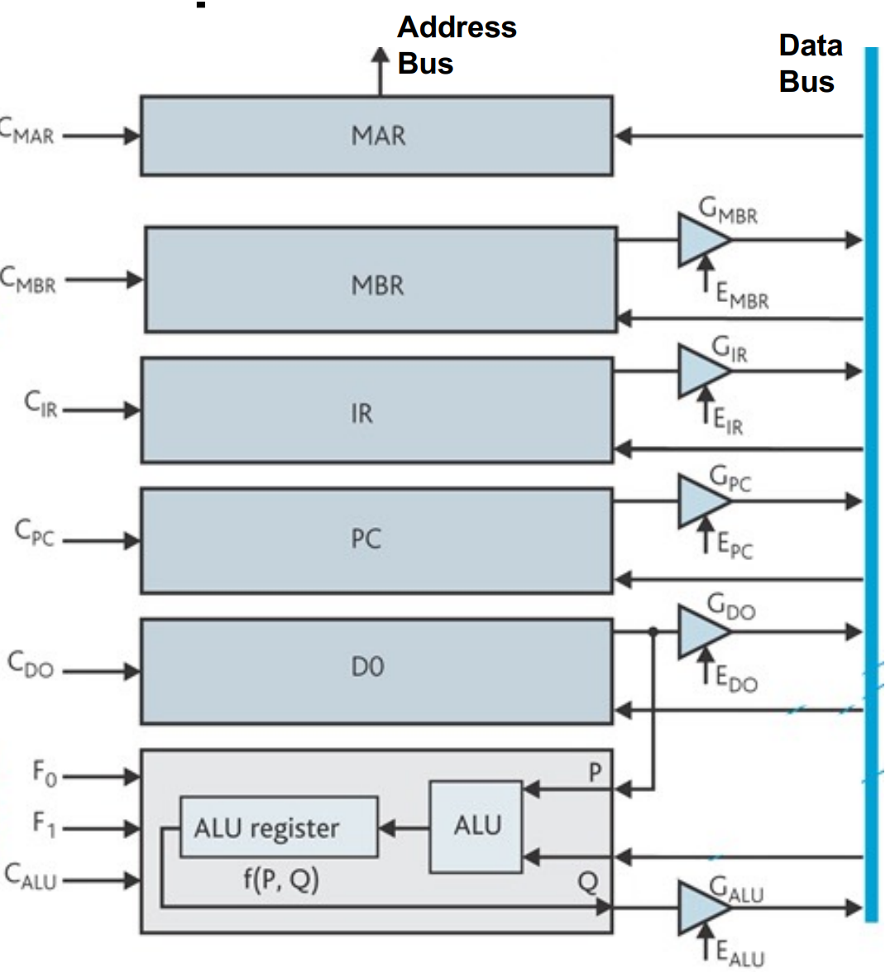
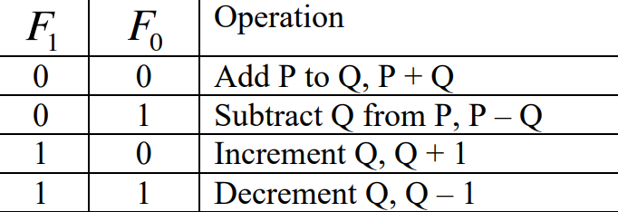

Table 1: Arithmetic Functions Defined by F0 and F1

Figure 1: Simple CPU Datapath

2 Analytical Design
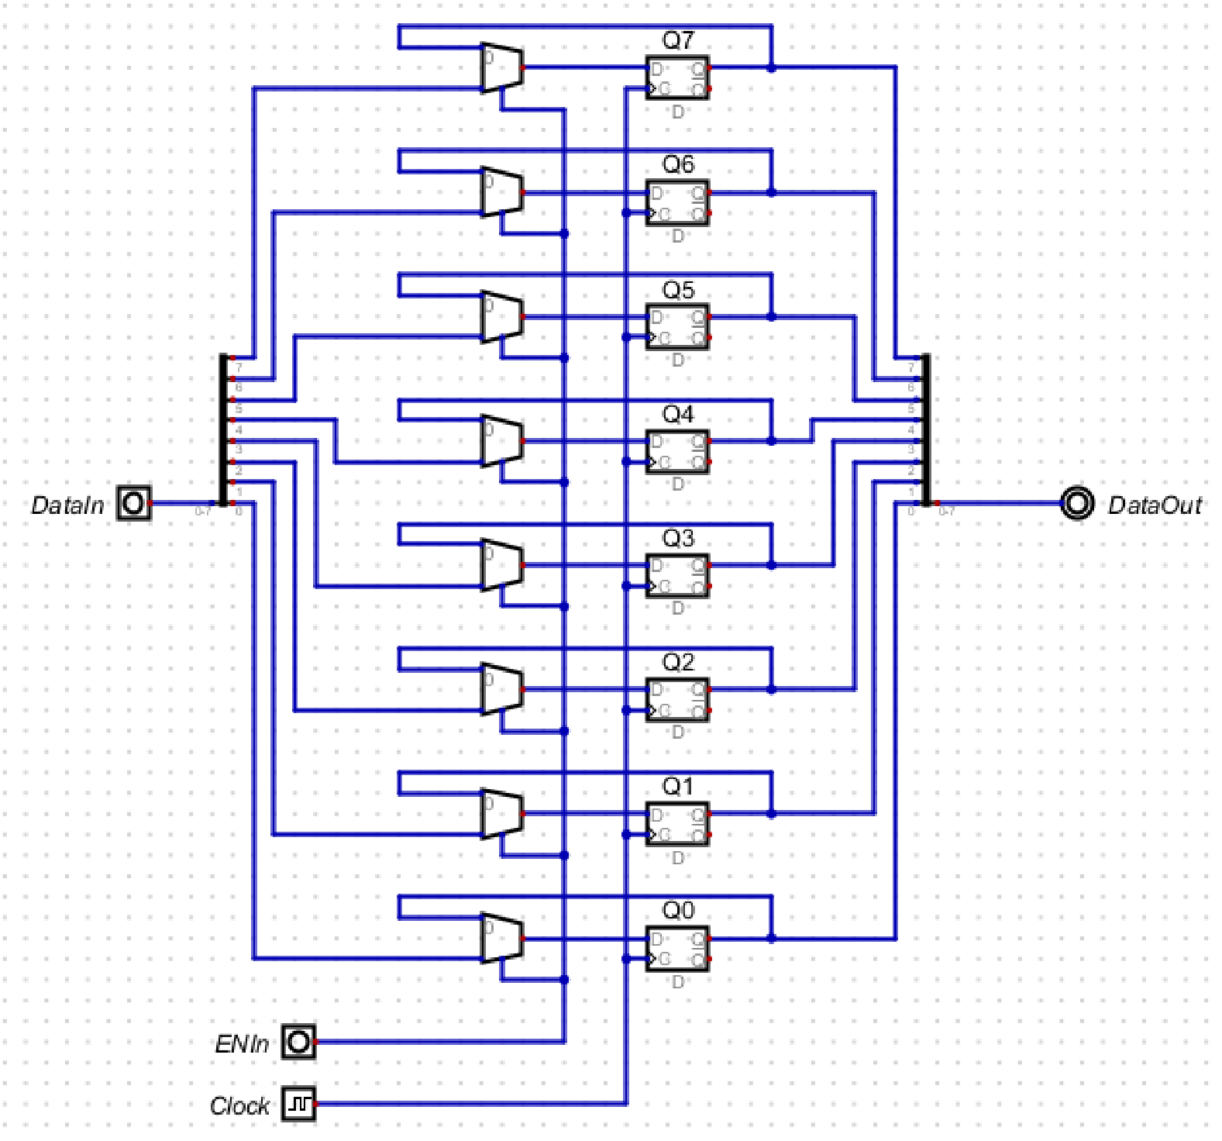
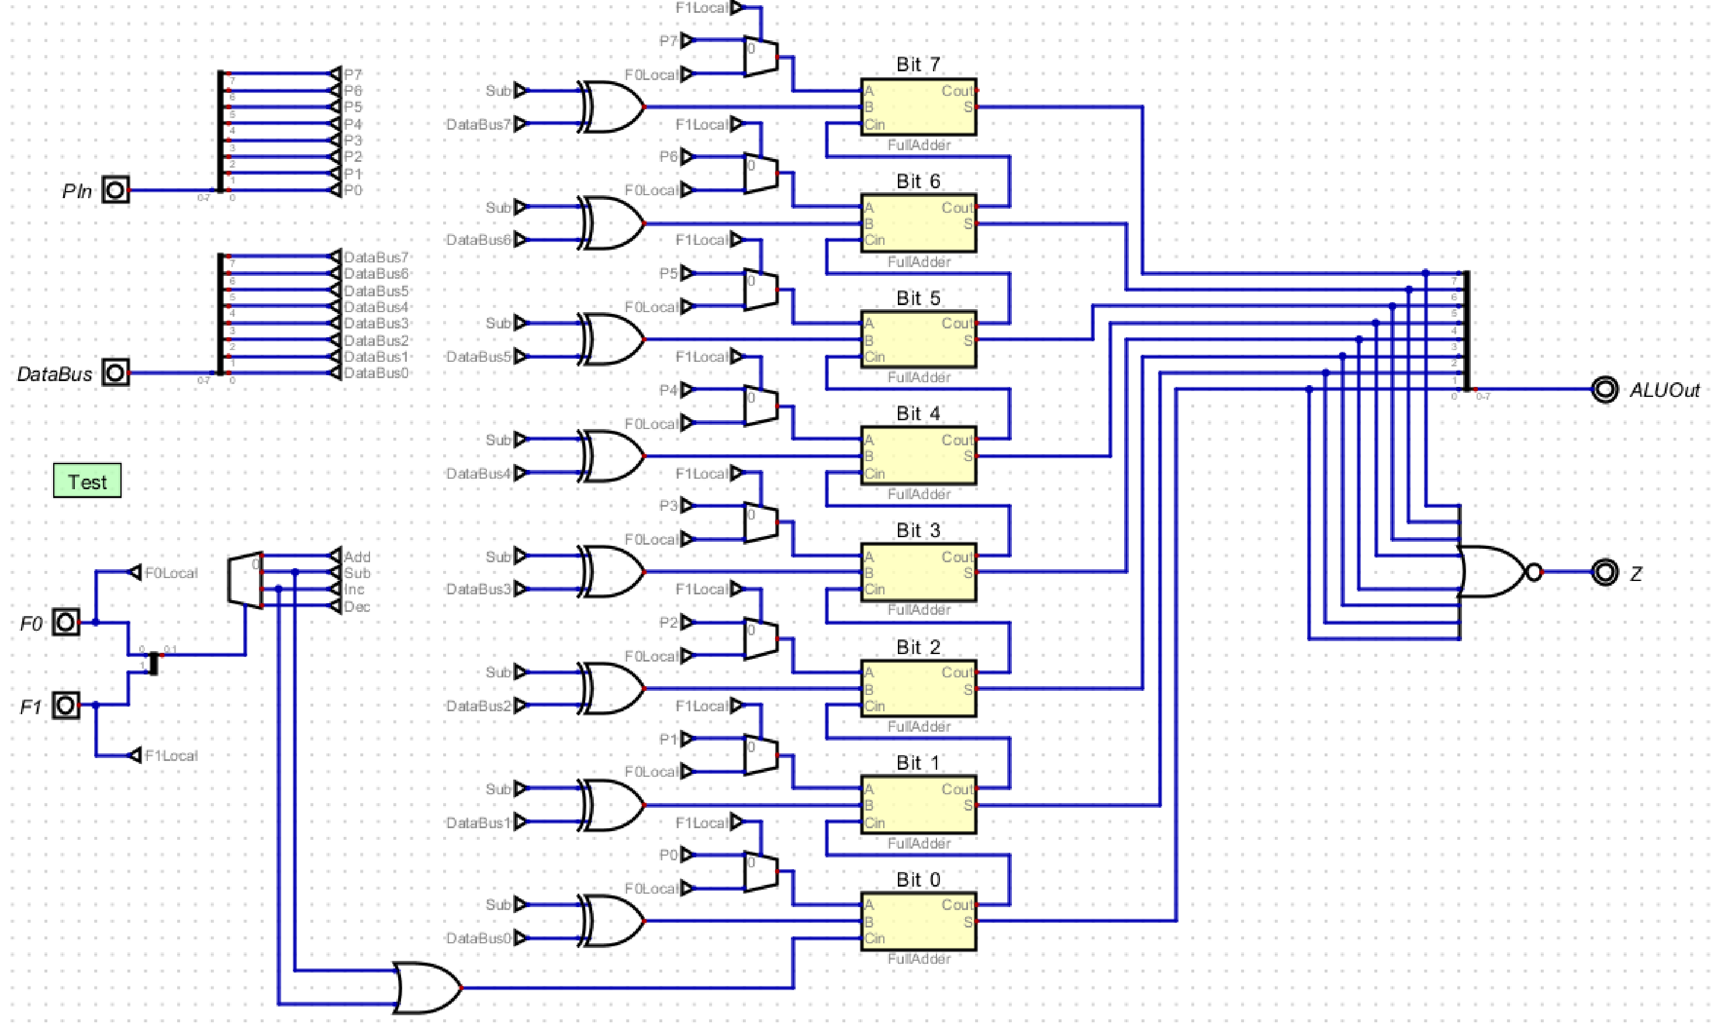
In this assignment, we created the Datapath, as shown in Figure 2. The Datapath consists of 6 identical registers labeled MAR, MBR, IR, PC, D0, and ALU, which is shown in Figure 3. Each register was constructed using 8 multiplexers and D Flip-Flops, and is used to hold an instruction, address, or any kind of data. The ALU is shown in Figure 4, which contains an 8-bit ripple carry adder comprised of 8 Full-adders, shown in Figure 5. This assignment also required us to bring the whole CPU together, which is shown as a fully integrated/embedded circuit in Figure 6.
Figure 4: ALU Circuit
Figure 3: Register Circuit
Figure 2: Datapath Circuit
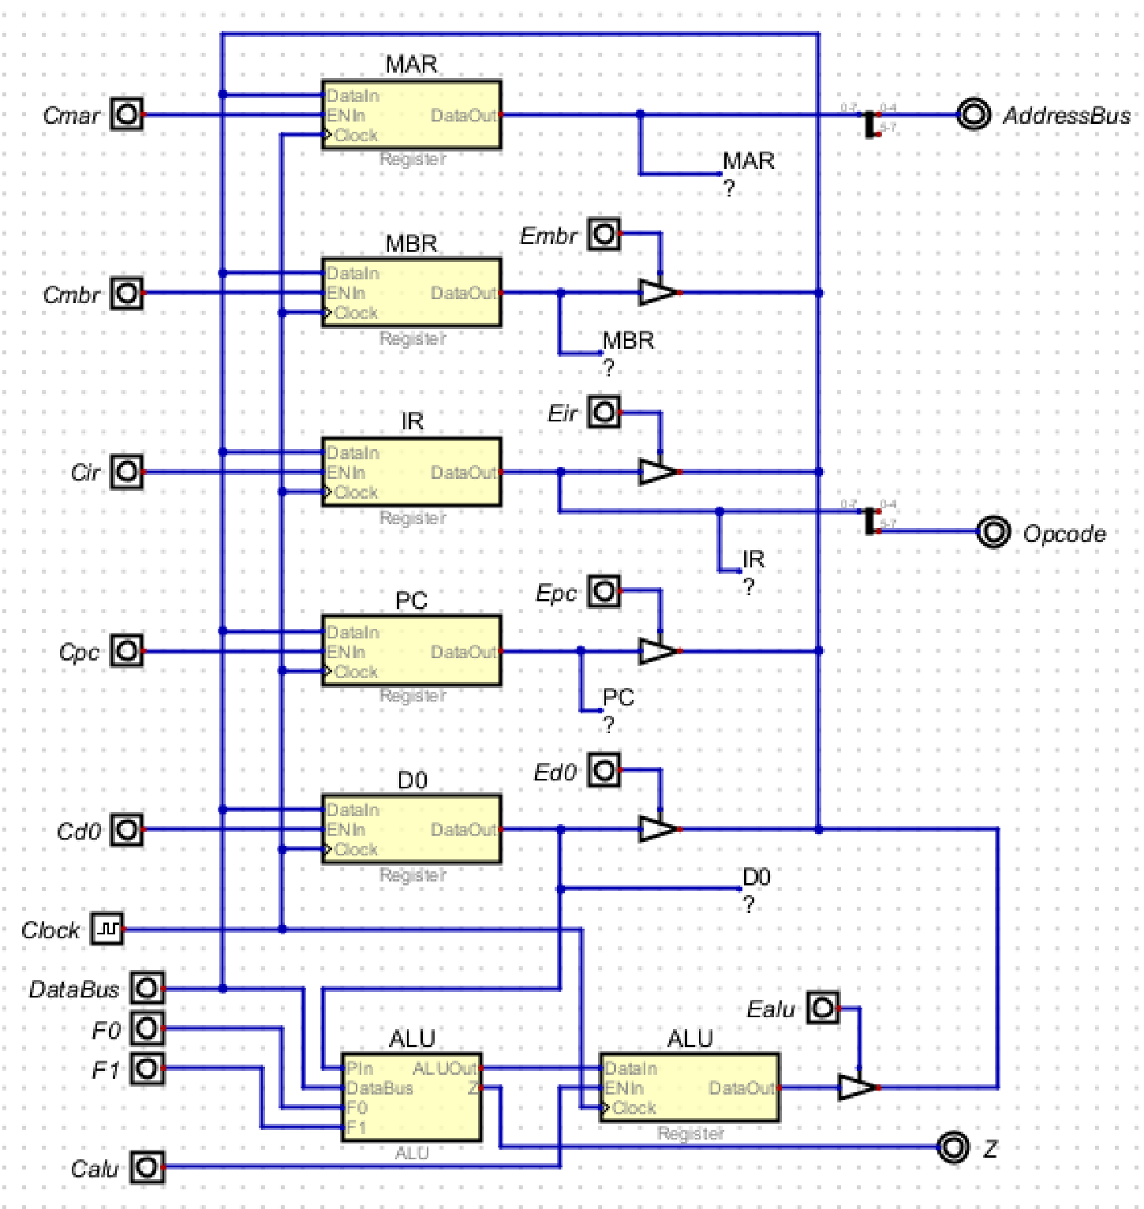

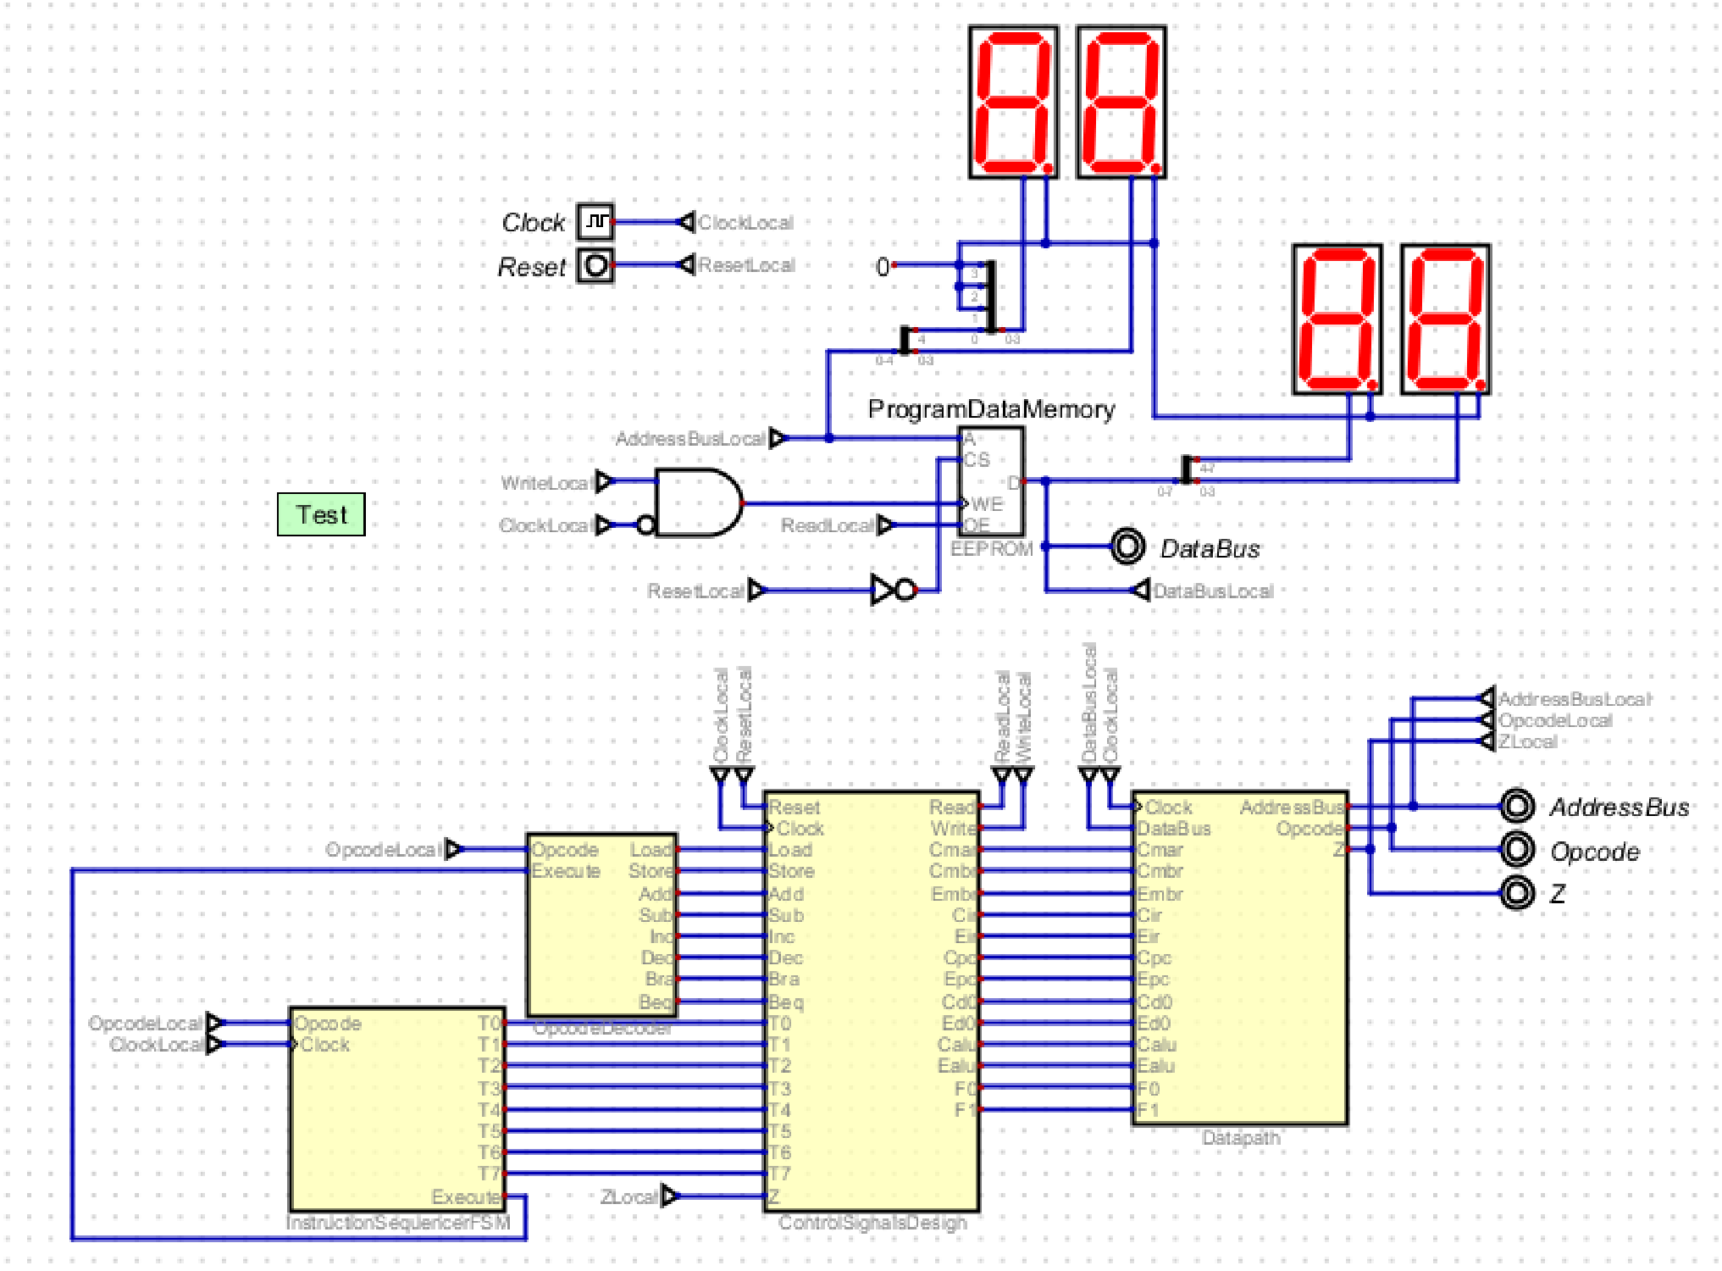
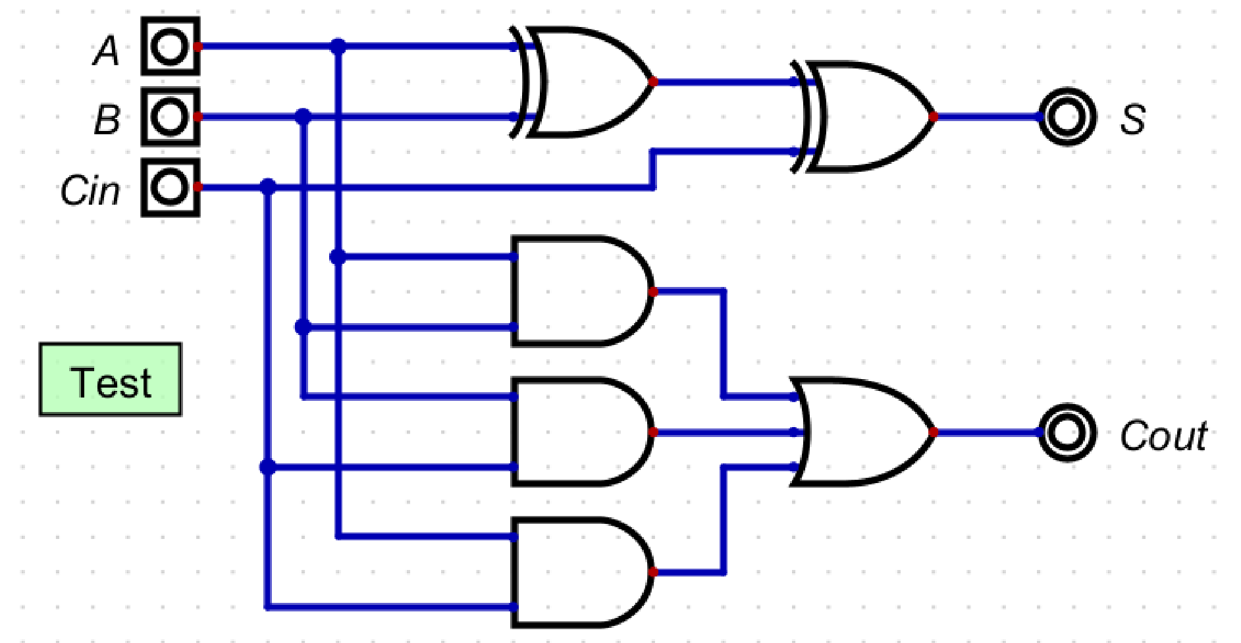
Figure 5: Full Adder Circuit

Figure 6: Simple CPU Diagram

3 Numerical Verification
This assignment required a number of separate circuits to fully complete the CPU. Different components of the CPU and Datapath had test vectors that were verified, in the order of increasing complexity. For all test vectors, a more comprehensive view can be seen in the .dig files provided. Figure 7 shows the results of the Full Adder, the most basic circuit created for this assignment. From there, the ALU itself was tested and verified by applying a number of random test vectors to ensure that all 4 arithmetic equations work as expected, and that is shown in Figure 8 and Figure 9. After that, we jumped to the Simple CPU itself, and tested that in two ways. The first way was with the provided Measurement Graph Results as test vectors. The vectors and results can be seen in Figure 10 and Figure 11. The second way was by creating a miniature program in itself, which executed 3 instructions: Load, Add, and Store. The ProgramDataMemory contents can be seen in Figure 12, and can be verified by running the machine, which will show the results on the Seven-Segment Hex Display as shown in the Simple CPU diagram.

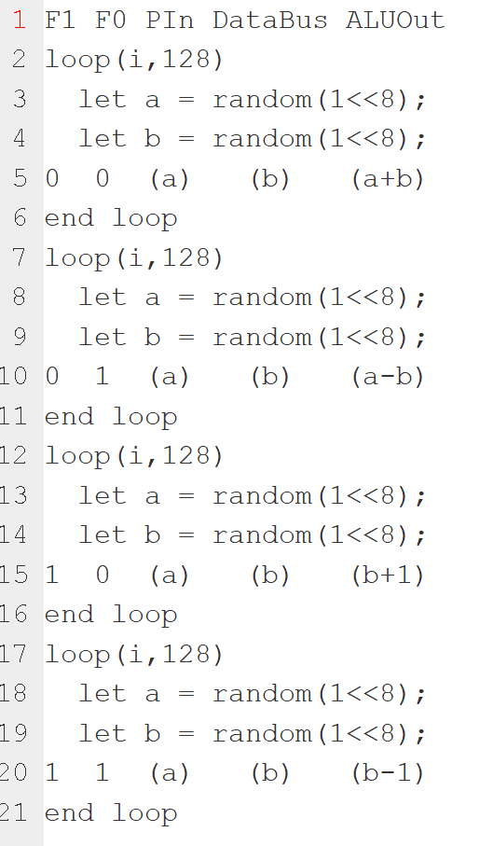
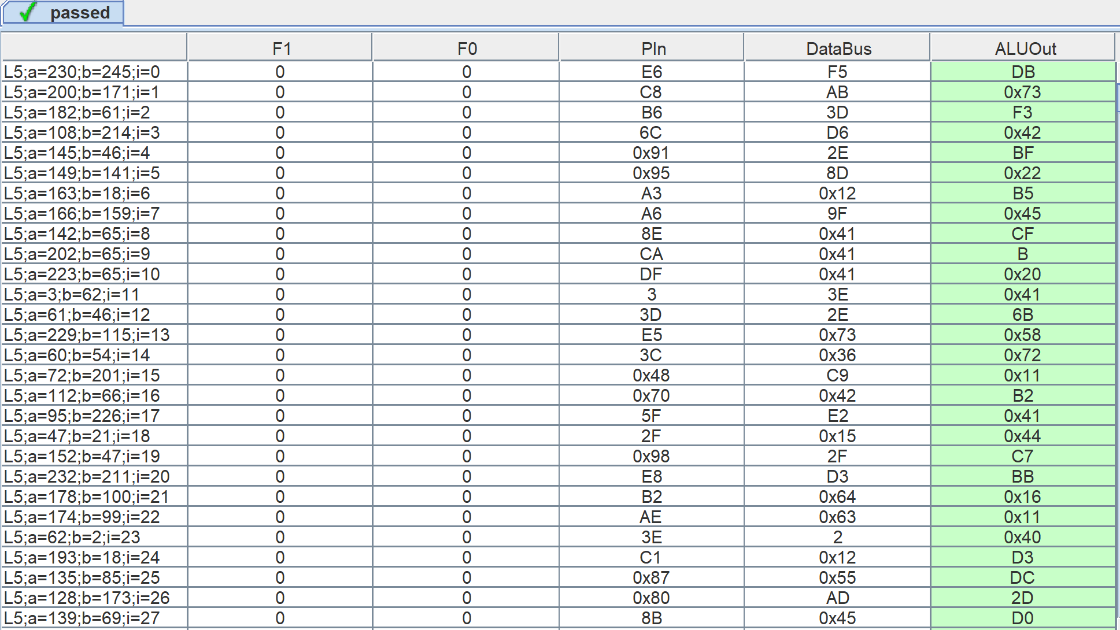
Figure 7: Full Adder Test Vectors
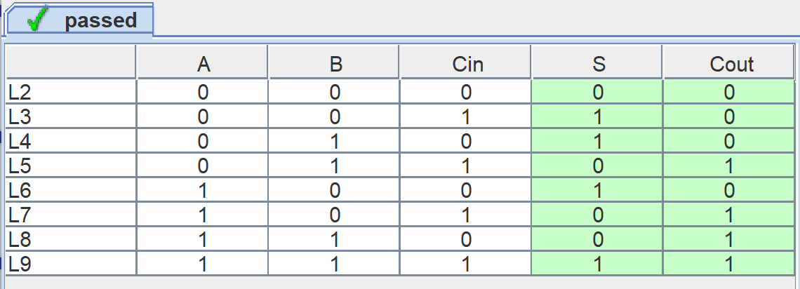
Figure 9: ALU Vector Results
Figure 8: ALU Vectors

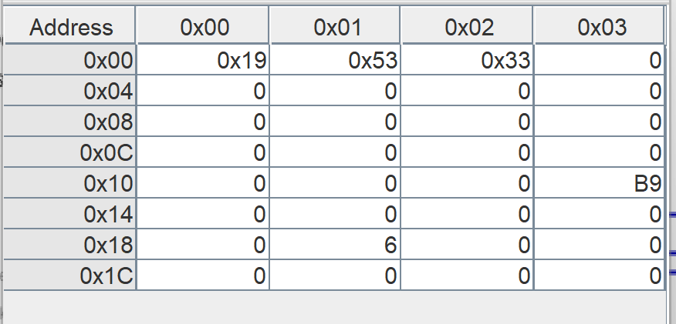
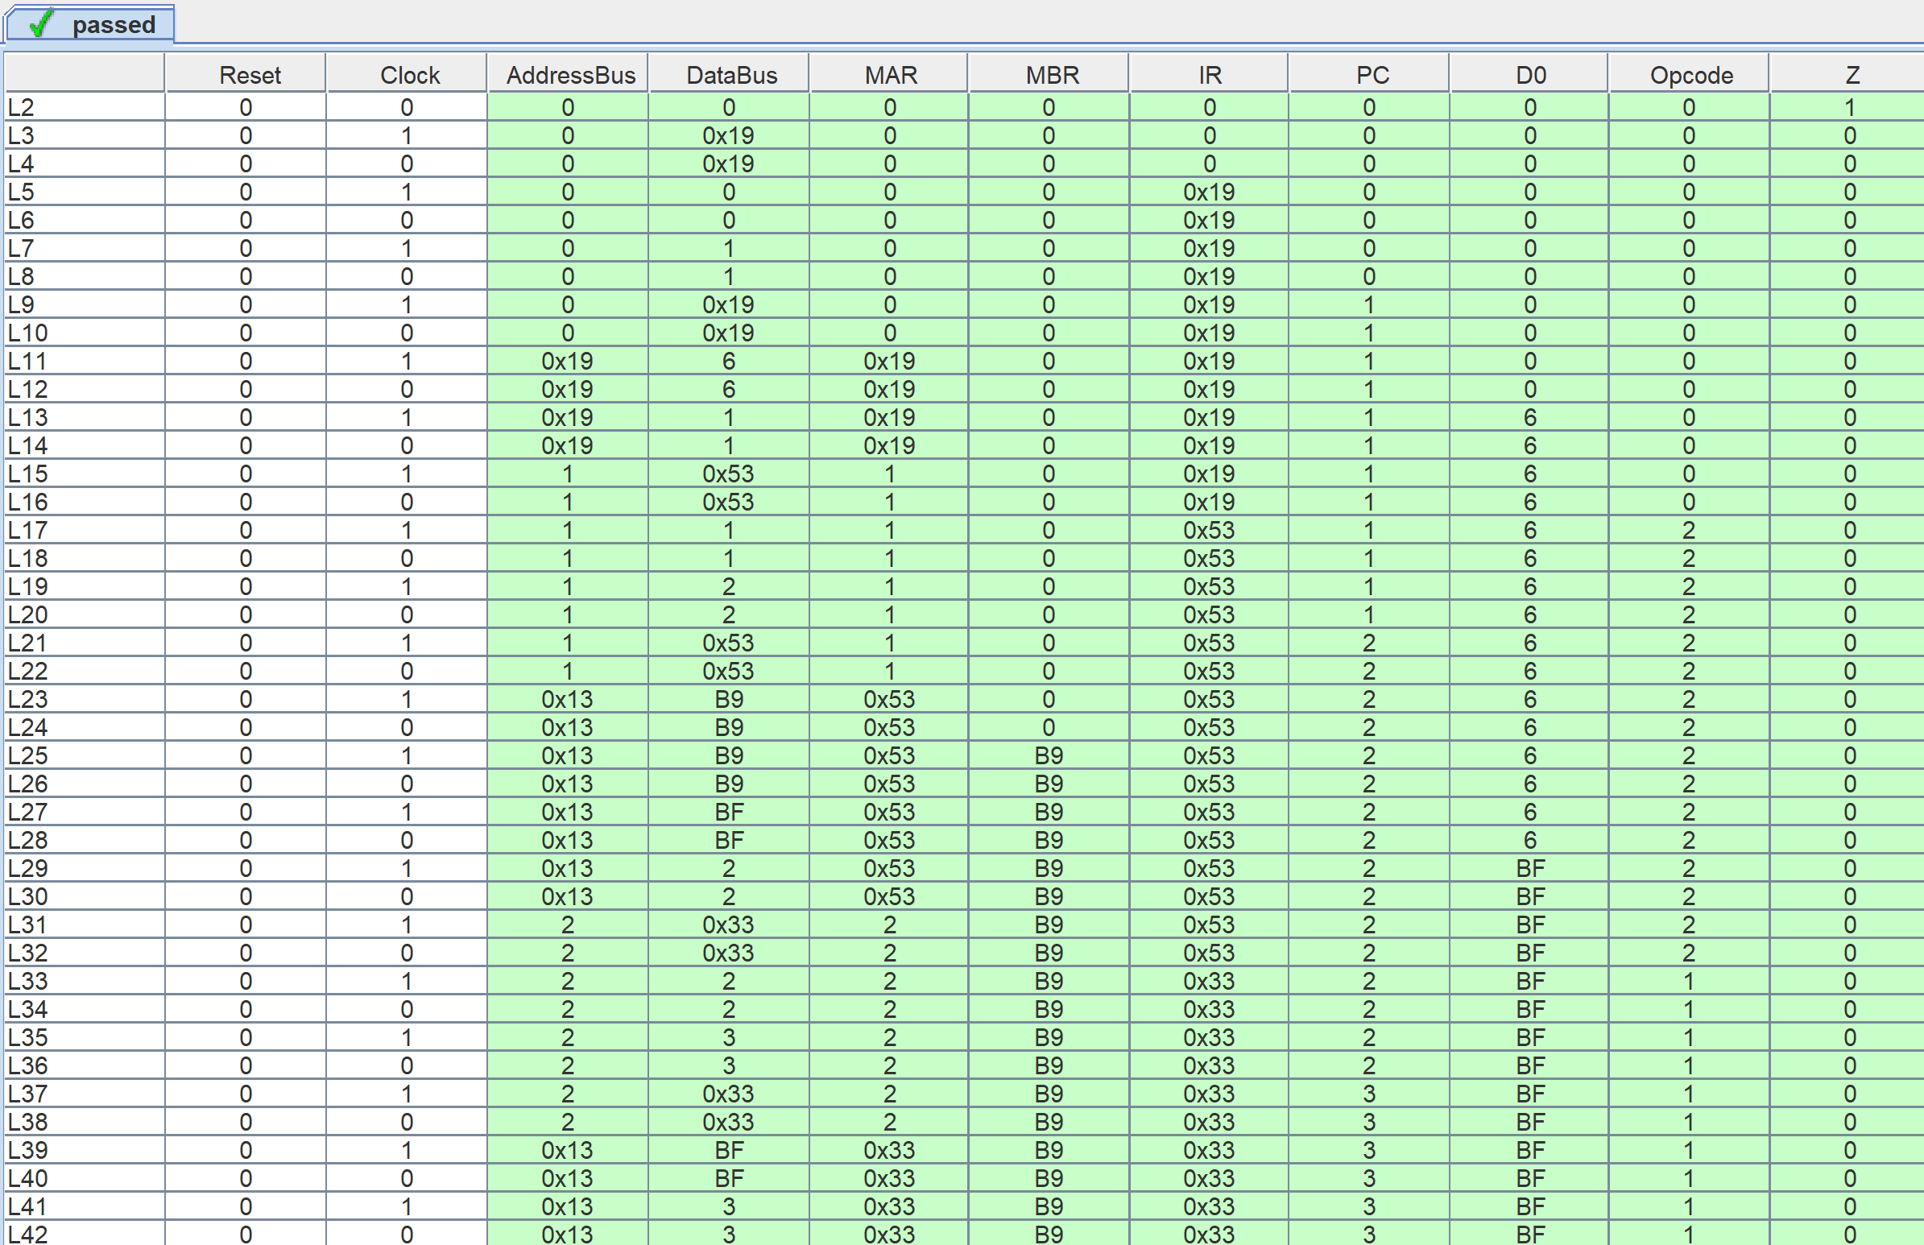
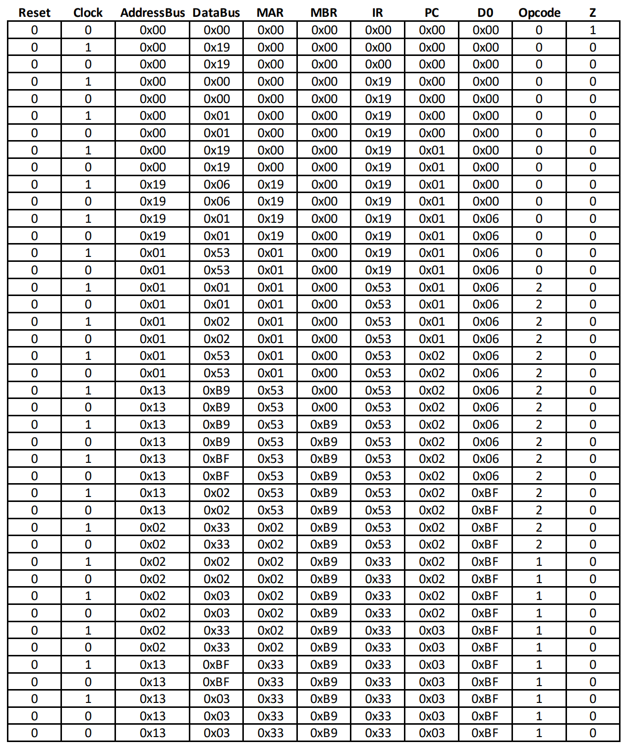
Figure 10: Simple CPU Test Vectors
Figure 11: Simple CPU Vector Results

Figure 12: ProgramDataMemory Contents
4 Summary
The problem requirement for this assignment was to generate the Datapath, which consisted of six register and the ALU (which consisted of an 8-bit carry-ripple adder, which consisted of 8 full-adders), and incorporate that into the overall Simple CPU design itself along with all of the other components. The previous CPU components were tested in prior weeks, but the parts designed this week as well as the CPU as a whole were tested thoroughly to ensure proper performance. Therefore, we can say that our solution successfully completed the project requirements.

